4.1
4.1.1
Make it small? I’m not sure what else to say

4.2
- Use lightweight materials
- Carbon fiber ($$$)
- Aluminum
- Polycarbonate
- Acrylic? (cracks)
- Use flanged plates for high strength to weight parts
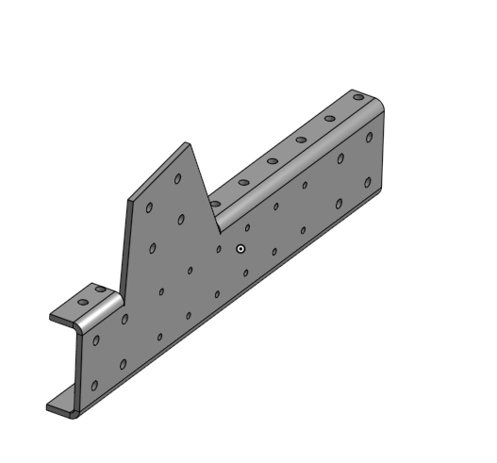
- Pocket plates
- Use thinner sizes of materials as opposed to pocketed parts
- Use rivets instead of bolts
  - Rivets are permanent so maintenance will require some bolts
4.3
- 4.3.1
  - Custom parts should be relatively simple in design
  - Consider Design for Manufacturing principles while designing parts (DFM)
  - Have raw stock on hand?
- 4.3.2
  - McMaster-Carr is very quick and sells it all ($$$)
  - Most COTS items sho uld arrive in 15 days if they are shipping from USA
  - We need a quick purchasing system
    - If it is a reimbursement system this may be challenging on high ticket items
- 4.3.3

- 4.3.4
  - Use normal materials
    - Aluminum
    - Carbon fibre
    - Hdpe
    - Polycarbonate
  - Don’t use weird metals like gallium?
  - No hot glue
- 4.3.5
  - Order more than the ROV’s quantity in the first order
- 4.3.6
  - Stainless steel hardware
  - Aluminium for exterior metals
  - Plastics shouldn't be a problem?
  - Powder coat or anodize metal parts
4.4
- 4.4.1
  - Plastics can be used as a nonconductive
  - Electronics shouldn't be open
- 4.4.2
  - Avoid leaded steel?
  - Avoid leaded solder
    - This may be a detriment as unleaded solder is worse
  - Don’t use ABS Plastic as it can make fumes during printing
- 4.4.3, 4.4.4
  - Handmade custom parts:
    - Debur/chamfer all edges
  - CNC/Outsources custom parts:
    - Fillet corners and edges as applicable
  - COTS parts
    - debur/chamfer as needed
4.5
- 4.5.1
  - Use o-ring seals on all commonly open areas
  - Use epoxy or silicone to seal joints
  - Use proven and rated bulkhead connectors for wiring
  - Conformal coating on electronics
- 4.5.2
  - Billet Aluminum housing
    - O-rings inset in housing faceplates
    - Bolt clamping ring
  - Polycarbonate cylindrical tube
  - O-rings inset in billet aluminum endcaps
    - Could be 3d printed too
  - COTS electronics housing rated for depth
4.6
- 4.6.1
  - Thermal paste between hot electronics to metal plate
  - Metal plates can also border outside for easy cooling
4.7
- 4.7.1 Fasteners
  - Use M2,M3,M4, etc sized threaded hardware
    - Socket head bolts
      - Unless clearance is needed or countersunk for some reason
    - Standardize drive heads for bolts
      - Torx head M4 and below
      - Hex for M5 and above
    - Use “standard” pitch bolts
      - Fine and coarse thread bolts are not applicable in 95% of uses
    - Use nylon locking nuts or threadlocker on dry parts

